Dynamically upload CSV files:

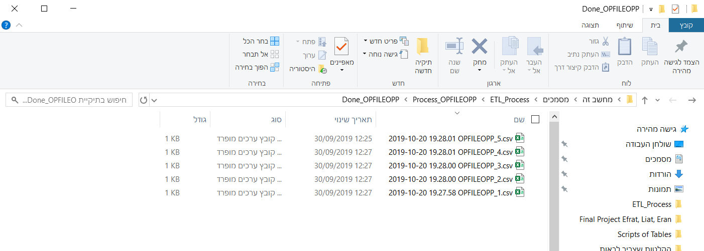1. OPFILEOPP files

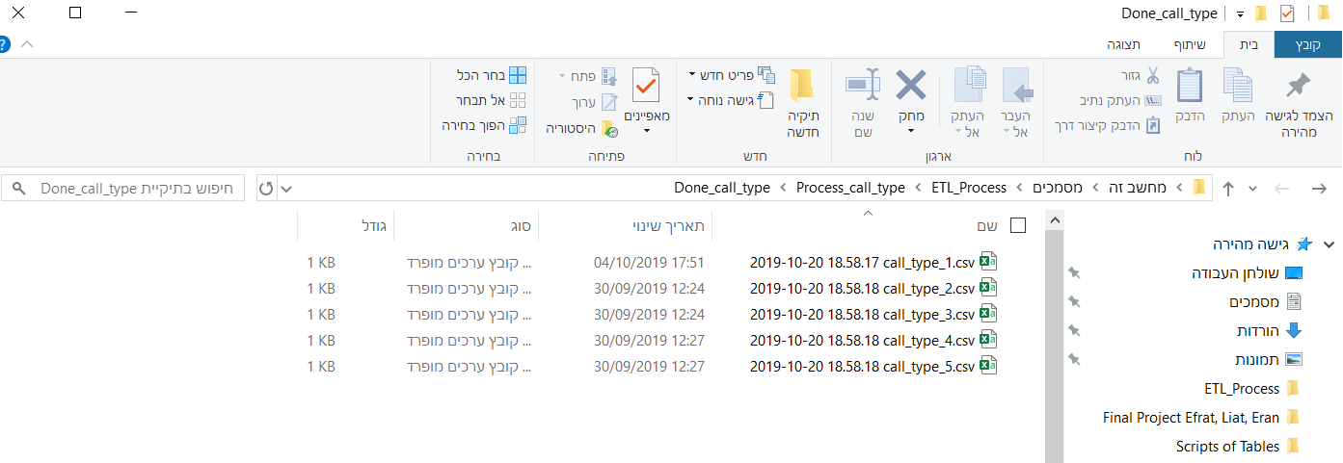2. Call_type files